Monthly Performance Report – November 2025
Kestrel Ridge Wind Farm (75.6 MW)
David Chen · 09 December 2025 · KR-OPS-RPT-2025-11

1. Summary
Kestrel Ridge generated 21.3 GWh in November 2025, 1.4 % below the P50 budget of 21.6 GWh. Time-based availability was strong at 97.6 % (contract target 97.0 %). Mean hub-height wind speed of 9.1 m/s was close to the long-term mean (9.1 m/s). Compared with November 2024 (20.9 GWh), output was up 0.4 GWh.
The oil sample from T-07 taken on 4 November showed slightly elevated iron (38 ppm) – flagged as "watch" by the laboratory. In hindsight this was the first sign of the bearing damage that led to KR-INC-2026-003.

2. Production and key figures
KPI | November 2025 | Budget / target | YTD 2025 | YTD budget
Net generation (GWh) | 21.3 | 21.6 | 181.7 | 189.0
Time-based availability | 97.6 % | 97.0 % | 97.4 % | 97.0 %
Capacity factor | 39.1 % | 39.7 % | 30.0 % | –
Mean wind speed at hub height (m/s) | 9.1 | 9.1 | – | –
Source: Kestrel Ridge SCADA, revenue meter at 132 kV point of connection. Budget = P50 (2024 post-construction yield assessment).
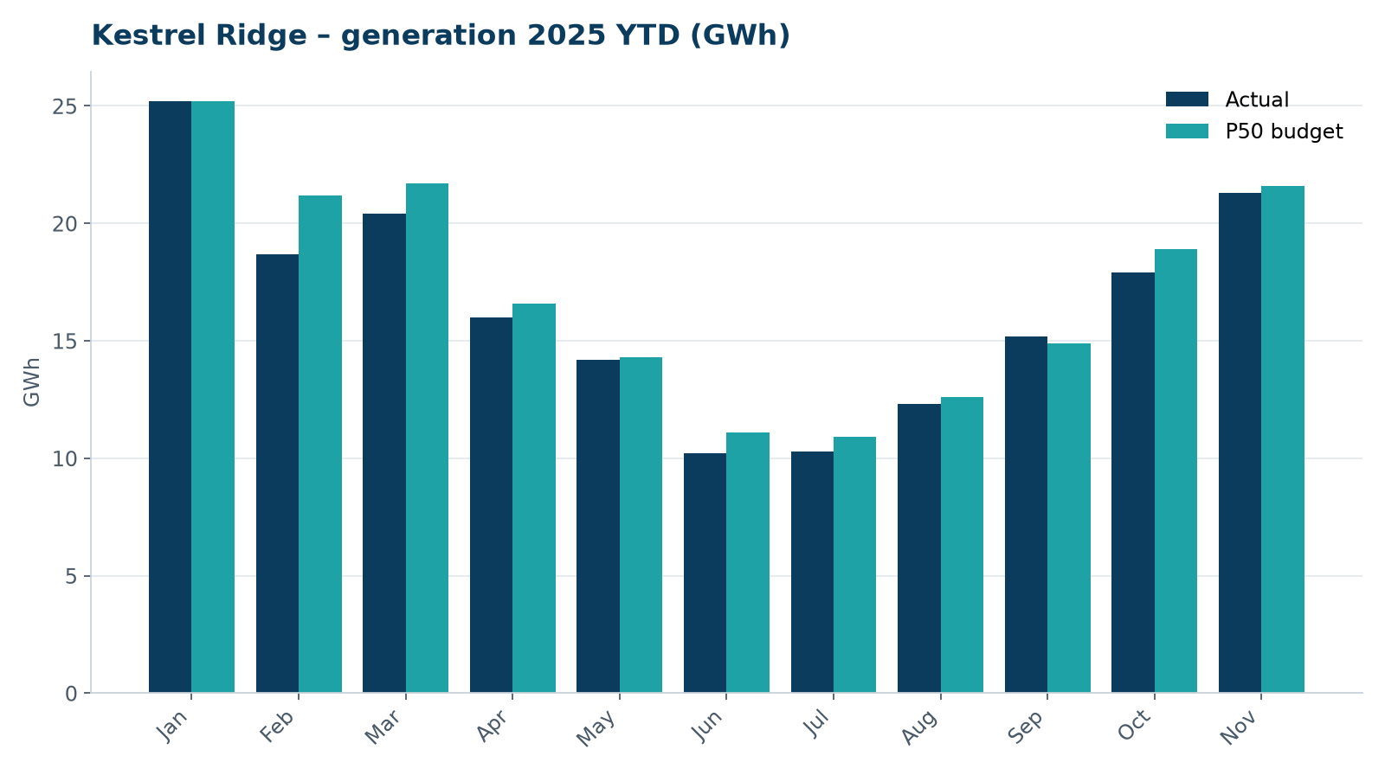
Monthly generation vs. P50 budget, 2025 year to date

3. Availability and downtime
Total turbine downtime attributable to the contractor amounted to 51 turbine-hours for the top events listed below. No grid or force majeure exclusions were claimed this month.
Turbine | Event | Downtime (h)
T-10 | nacelle cooling fan motor failure | 17
T-16 | high-voltage transformer gas relay alarm (inspected, no fault found) | 12
T-16 | generator slip ring brush wear alarm | 12
T-08 | high-voltage transformer gas relay alarm (inspected, no fault found) | 5
T-07 | anemometer heater failure – sensor replaced | 5
Top downtime events of the month (SCADA event log, reviewed with Highline Wind Services).

4. Maintenance
- 15 corrective work orders closed, 4 still open at month end.
- Substation monthly inspection completed; no abnormalities on the 33/132 kV transformer.

5. Health, safety and environment
Indicator | Month
Hours worked on site (Highline + Weyland) | 2,575
Lost time injuries | 0
First aid cases | 0
Near misses reported | 0
Safety observations | 14
Environmental incidents | 0

No complaints from neighbours were received this month.

6. Outlook
We will review the downtime events above with Highline in the monthly O&M meeting and track the recurring pitch faults.
Prepared by Sara Lindgren (Performance Analyst); reviewed by Ben Okoye (Site Manager) and David Chen (Asset Operations Manager).

